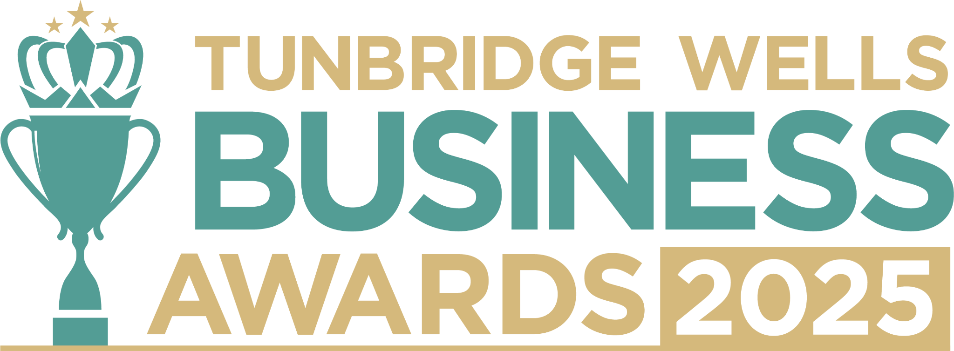

**Changemaker Award, sponsored by Sevenoaks District Chamber of Commerce.** This Award celebrates businesses, organisations, or individuals who are driving meaningful change in their community or industry. We want to hear how you’re leading with integrity, showing a commitment to sustainability, or championing ethical business practices - and the difference this is making. All entries will be treated in confidence and reviewed only by our judging panel and team. **Please submit your entry as a Word document to** [**info@thetncard.com**](mailto:info@thetncard.com) **by 5pm on 20th October. Any supporting evidence should be sent as a separate document (max 2 pages).**

**1. Business information**

|  |  |  |  |
| --- | --- | --- | --- |
| Business name: |  | | |
| Business address: |  | | |
| Date started: |  | No. of employees: Including owners and part-time staff |  |
| 2023 turnover:  Optional - enables judges  to assess growth |  | 2024 turnover: Optional - enables judges to assess growth |  |
| Website address: |  | | |
| Social media links: |  | | |

**2. Applicant information**

|  |  |
| --- | --- |
| Name: |  |
| Role: |  |
| Email and phone number: |  |

**3. About your business**

3a. Describe your business in one sentence.

3b. Tell us about your products or services, and the people you serve. Maximum 300 words.

**4. Ethical and community focused practices**

4a. How do you embed ethical principles or sustainability into the way you run your business? Maximum 300 words.

4b. What positive difference do your products or services make to our community or the planet? Maximum 300 words.

4c. How do you look after the wellbeing of your team as part of your changemaking values? Maximum 300 words.

4d. How do you make a difference to Tunbridge Wells life? Maximum 300 words.

**5. Innovation and growth**

5a. What innovative solutions or approaches has your business introduced to create social or environmental change? Maximum 300 words.

5b. What are your future goals for continuing to create positive change through your business? Maximum 300 words.

***Terms and conditions***

*By submitting this entry form, you agree to the following:*

* ***Entry deadline:*** *All entries must be received by 5pm on Monday 20th October 2025. Late entries will not be considered.*
* ***Finalist attendance:*** *Finalists are required to attend the Tunbridge Wells Business Awards evening at Trinity Theatre on Wednesday 19th November 2025. This ensures fairness to all entrants and supports the running of the awards. Please confirm your availability before entering.*
* ***Eligibility:*** *The awards are open to businesses in postcodes TN1 – TN6, Bidborough and Hawkhurst.*
* ***Accuracy of information:*** *All comments made on your application form, and any supporting evidence provided, must be accurate. Entries may be fact-checked, and additional evidence or information may be requested.*
* ***Judging:*** *The judges’ decision is final. We are unable to provide feedback, and entries will not be returned.*
* ***Publicity:*** *By entering the Tunbridge Wells Business Awards, you agree to participate in publicity relating to the awards, including the use of any photography taken before or at the event.*