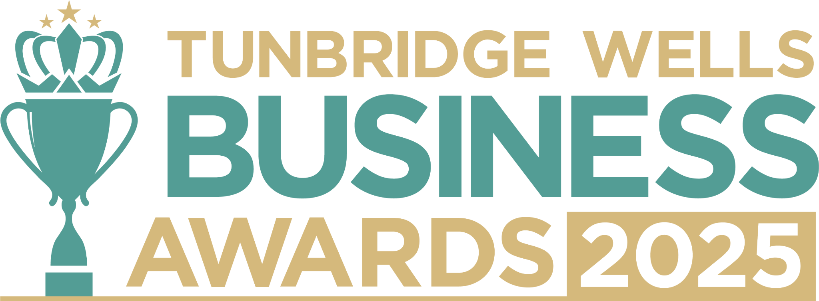

**Retail Award.** Are you the owner of a retail business that brings something special to our high streets or local shopping community? We’d love to hear what sets you apart in your industry and how you’re making a difference locally. All entries will be treated in confidence and reviewed only by our judging panel and team. **Please submit your entry as a Word document to** [**info@thetncard.com**](mailto:info@thetncard.com) **by 5pm on 20th October. Any supporting evidence should be sent as a separate document (max 2 pages).**

**1. Business information**

|  |  |  |  |
| --- | --- | --- | --- |
| Business name: |  | | |
| Business address: |  | | |
| Date started: |  | No. of employees: Including owners and part-time staff |  |
| 2023 turnover:  Optional - enables judges  to assess growth |  | 2024 turnover: Optional - enables judges to assess growth |  |
| Website address: |  | | |
| Social media links: |  | | |

**2. Applicant information**

|  |  |
| --- | --- |
| Name: |  |
| Role: |  |
| Email and phone number: |  |

**3. About your business**

3a. Describe your business in one sentence.

3b. What products do you sell, and what is the heart of your retail business? Maximum 300 words.

3c. What makes your business unique in the marketplace and why do customers choose you over larger or online competitors? Maximum 300 words.

**4. Achievements and innovation**

4a. How have you demonstrated innovation and excellence in your industry, whether through product ranges, customer experience or new ways of trading? Maximum 300 words.

4b. How do you go above and beyond to give customers a memorable experience? Maximum 300 words.

4c. How do you build loyalty and long-term relationships with your customers? Maximum 300 words.

4d. What challenges have you faced this past year as a retail business, and how have you overcome them? Maximum 300 words.

**5. Sustainability and community**

5a. What sustainability or ethical retail practices are part of your business, and why are they important to you? Maximum 300 words.

5b. Are you involved in any local partnerships or community work? Maximum 300 words.

***Terms and conditions***

*By submitting this entry form, you agree to the following:*

* ***Entry deadline:*** *All entries must be received by 5pm on Monday 20th October 2025. Late entries will not be considered.*
* ***Finalist attendance:*** *Finalists are required to attend the Tunbridge Wells Business Awards evening at Trinity Theatre on Wednesday 19th November 2025. This ensures fairness to all entrants and supports the running of the awards. Please confirm your availability before entering.*
* ***Eligibility:*** *The awards are open to businesses in postcodes TN1 – TN6, Bidborough and Hawkhurst.*
* ***Accuracy of information:*** *All comments made on your application form, and any supporting evidence provided, must be accurate. Entries may be fact-checked, and additional evidence or information may be requested.*
* ***Judging:*** *The judges’ decision is final. We are unable to provide feedback, and entries will not be returned.*
* ***Publicity:*** *By entering the Tunbridge Wells Business Awards, you agree to participate in publicity relating to the awards, including the use of any photography taken before or at the event.*