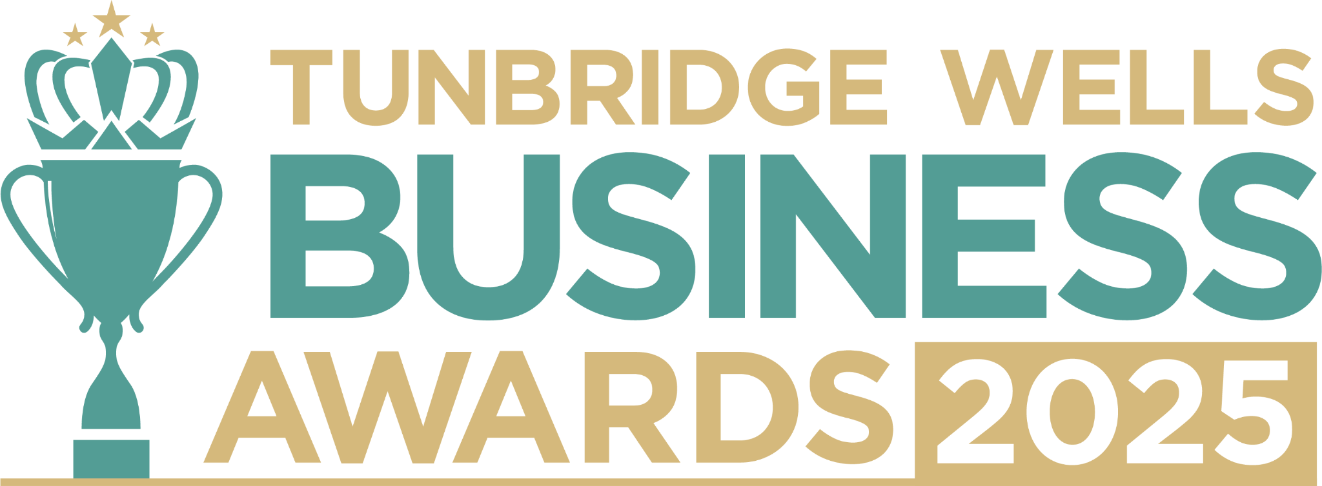

**Creative Business Award, sponsored by chilliapple.** Are you the owner of a business in the creative, design, marketing or PR sector? We’d love to hear what makes your work stand out and how you’re using creativity to make a difference in our community. All entries will be treated in confidence and reviewed only by our judging panel and team. **Please submit your entry as a Word document to** [**info@thetncard.com**](mailto:info@thetncard.com) **by 5pm on 20th October. Any supporting evidence should be sent as a separate document (max 2 pages).**

**1. Business information**

|  |  |  |  |
| --- | --- | --- | --- |
| Business name: |  | | |
| Business address: |  | | |
| Date started: |  | No. of employees: Including owners and part-time staff |  |
| 2023 turnover:  Optional - enables judges  to assess growth |  | 2024 turnover: Optional - enables judges to assess growth |  |
| Website address: |  | | |
| Social media links: |  | | |

**2. Applicant information**

|  |  |
| --- | --- |
| Name: |  |
| Role: |  |
| Email and phone number: |  |

**3. About your business**

3a. Describe your business in one sentence.

3b. Tell us about the creative services or products you offer, and how they inspire or support your customers. Maximum 300 words.

3c. What makes your business unique in the creative industry and how do you bring originality or fresh ideas into your work? Maximum 300 words.

**4. Achievements and innovation**

4a. What major milestones or successes has your business achieved in the past year? Maximum 300 words.

4b. How has your creativity made a difference to your clients, customers, or community? Maximum 300 words.

4c. What challenges have you faced as a creative business, and what did you learn from overcoming them? Maximum 300 words.

4d. What innovative ideas, techniques, or creative processes have you introduced to push boundaries in your work? Maximum 300 words.

**5. Sustainability and community**

5a. Do you implement any sustainability or ethical creative practices and why are these important to you? Maximum 300 words.

5b. Are you involved in any community initiatives or collaborations? Maximum 300 words.

***Terms and conditions***

*By submitting this entry form, you agree to the following:*

* ***Entry deadline:*** *All entries must be received by 5pm on Monday 20th October 2025. Late entries will not be considered.*
* ***Finalist attendance:*** *Finalists are required to attend the Tunbridge Wells Business Awards evening at Trinity Theatre on Wednesday 19th November 2025. This ensures fairness to all entrants and supports the running of the awards. Please confirm your availability before entering.*
* ***Eligibility:*** *The awards are open to businesses in postcodes TN1 – TN6, Bidborough and Hawkhurst.*
* ***Accuracy of information:*** *All comments made on your application form, and any supporting evidence provided, must be accurate. Entries may be fact-checked, and additional evidence or information may be requested.*
* ***Judging:*** *The judges’ decision is final. We are unable to provide feedback, and entries will not be returned.*
* ***Publicity:*** *By entering the Tunbridge Wells Business Awards, you agree to participate in publicity relating to the awards, including the use of any photography taken before or at the event.*