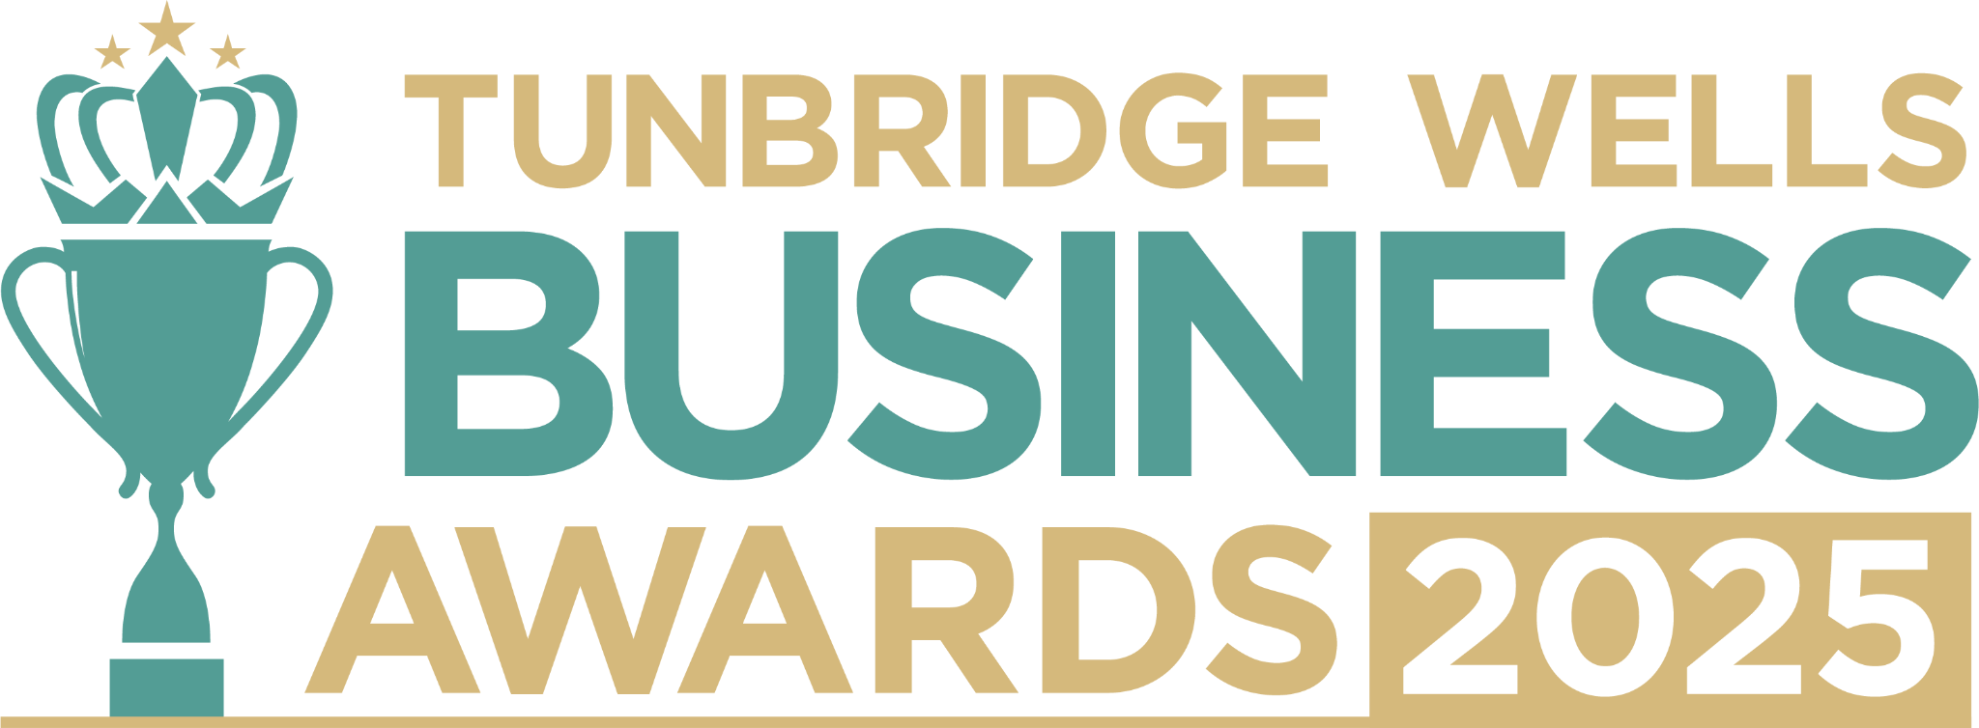

**Health and Wellbeing Award, sponsored by TWPT.** Are you a business dedicated to helping people live healthier, happier lives? Whether you’re in fitness, therapy, beauty, nutrition, or any area of health and wellness, we want to celebrate you. We’d love to hear what sets you apart in your industry and how you’re making a positive difference to both your customers and our wider community. Entries will be treated in confidence and reviewed only by our judging panel. Please submit your completed form to [info@thetncard.com](mailto:info@thetncard.com) by **5pm on 20th October. Any supporting evidence should be sent as a separate document (max 2 pages).**

**1. Business information**

|  |  |  |  |
| --- | --- | --- | --- |
| Business name: |  | | |
| Business address: |  | | |
| Date started:  Month, Year |  | No. of employees: Including owners and part-time staff |  |
| 2023 turnover:  Optional - enables judges  to assess growth |  | 2024 turnover: Optional - enables judges to assess growth |  |
| Website address: |  | | |
| Social media links: |  | | |

**2. Applicant information**

|  |  |
| --- | --- |
| Name: |  |
| Role: |  |
| Email and phone number: |  |

**3. About your business**

3a. Describe your business in one sentence.

3b. Tell us about the health and wellbeing services or products you offer, and how they benefit your customers. Maximum 300 words.

3c. What makes your business unique in the health & wellbeing sector? Maximum 300 words.

**4. Achievements and impact**

4a. How have you demonstrated innovation or excellence in the health and wellbeing space? Maximum 300 words.

4b. How does your business positively impact the health and wellbeing of your customers? Maximum 300 words

4c. How do you look after the wellbeing of your own team? Max 300 words.

4d. How do you go above and beyond in caring for your customers? Maximum 300 words.

**5. Sustainability and community**

5a. What sustainability or ethical practices are part of your business, and why are they important to you? Maximum 300 words.

5b. Are you involved in any local partnerships or community work? Maximum 300 words.

***Terms and conditions***

*By submitting this entry form, you agree to the following:*

* ***Entry deadline:*** *All entries must be received by 5pm on Monday 20th October 2025. Late entries will not be considered.*
* ***Finalist attendance:*** *Finalists are required to attend the Tunbridge Wells Business Awards evening at Trinity Theatre on Wednesday 19th November 2025. This ensures fairness to all entrants and supports the running of the awards. Please confirm your availability before entering.*
* ***Eligibility:*** *The awards are open to businesses in postcodes TN1 – TN6, Bidborough and Hawkhurst.*
* ***Accuracy of information:*** *All comments made on your application form, and any supporting evidence provided, must be accurate. Entries may be fact-checked, and additional evidence or information may be requested.*
* ***Judging:*** *The judges’ decision is final. We are unable to provide feedback, and entries will not be returned.*
* ***Publicity:*** *By entering the Tunbridge Wells Business Awards, you agree to participate in publicity relating to the awards, including the use of any photography taken before or at the event.*