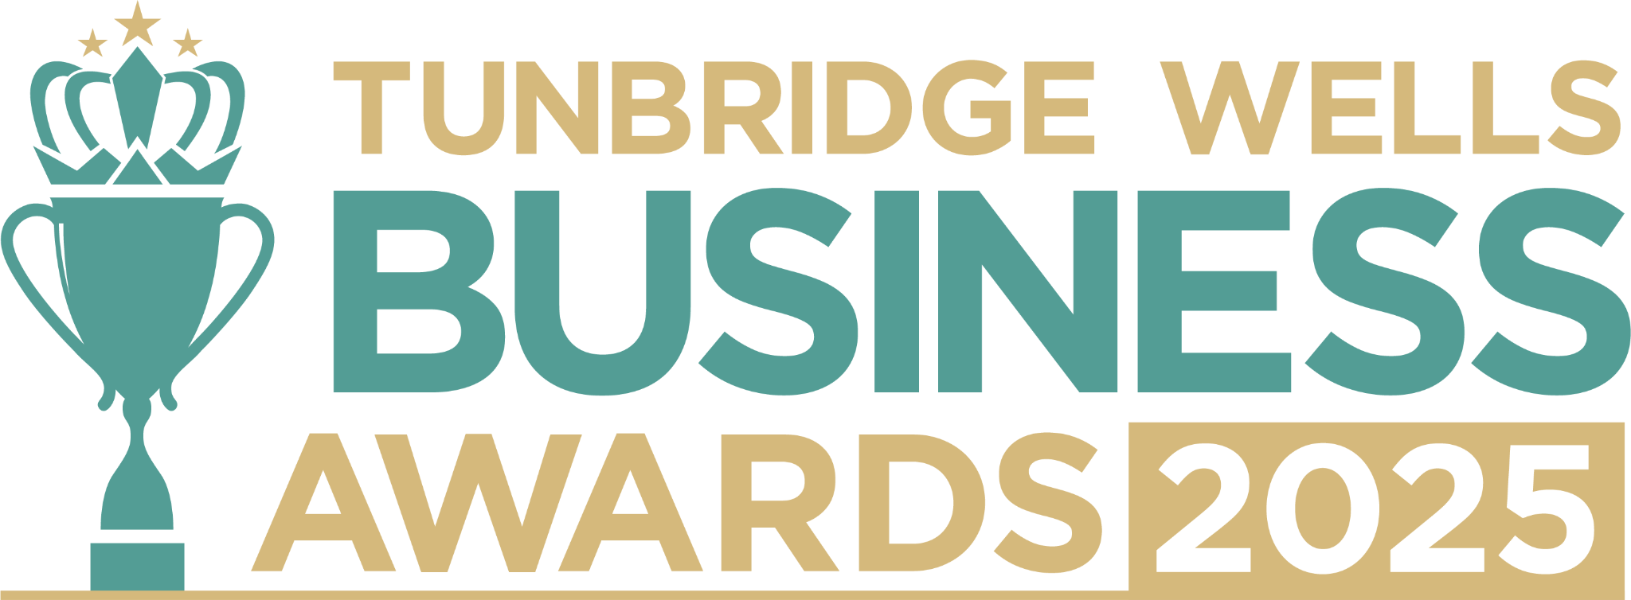

**Hair and Beauty Award**. Are you the owner of a hair or beauty business that helps people feel their best? We’d love to hear what makes you stand out in your sector, and how you’re making a positive difference in our community. All entries will be treated in confidence and reviewed only by our judging panel and team. **Please submit your entry as a Word document to** [**info@thetncard.com**](mailto:info@thetncard.com) **by 5pm on 20th October. Any supporting evidence should be sent as a separate document (max 2 pages).**

**1. Business information**

|  |  |  |  |
| --- | --- | --- | --- |
| Business name: |  | | |
| Business address: |  | | |
| Year started: |  | No. of employees: Including owners and part-time staff |  |
| 2023 turnover:  Optional - enables judges  to assess growth |  | 2024 turnover: Optional - enables judges to assess growth |  |
| Website address: |  | | |
| Social media links: |  | | |

**2. Applicant information**

|  |  |
| --- | --- |
| Name: |  |
| Role: |  |
| Email and phone number: |  |

**3. About your business**

3a. Describe your business in one sentence.

3b. Tell us about the hair or beauty services/products you offer, and who your customers are. Maximum 300 words.

3c. What makes your business unique in this sector and how do you help your clients feel special? Maximum 300 words.

**4. Achievements and innovation**

4a. How have you demonstrated innovation and excellence in your industry, whether through new treatments, techniques or ways of working with clients? Maximum 300 words.

4b. How do you go above and beyond to create an exceptional customer experience? Maximum 300 words.

4c. How do you support and develop your team to grow in their skills and confidence? Maximum 300 words

4d. How do you stay updated with trends and industry standards? Maximum 300 words.

**5. Sustainability and community**

5a. What sustainability or ethical practices are part of your business, and why do they matter to you? Maximum 300 words.

5b. Are you involved in any local partnerships or community work? Maximum 300 words.

***Terms and conditions***

*By submitting this entry form, you agree to the following:*

* ***Entry deadline:*** *All entries must be received by 5pm on Monday 20th October 2025. Late entries will not be considered.*
* ***Finalist attendance:*** *Finalists are required to attend the Tunbridge Wells Business Awards evening at Trinity Theatre on Wednesday 19th November 2025. This ensures fairness to all entrants and supports the running of the awards. Please confirm your availability before entering.*
* ***Eligibility:*** *The awards are open to businesses in postcodes TN1 – TN6, Bidborough and Hawkhurst.*
* ***Accuracy of information:*** *All comments made on your application form, and any supporting evidence provided, must be accurate. Entries may be fact-checked, and additional evidence or information may be requested.*
* ***Judging:*** *The judges’ decision is final. We are unable to provide feedback, and entries will not be returned.*
* ***Publicity:*** *By entering the Tunbridge Wells Business Awards, you agree to participate in publicity relating to the awards, including the use of any photography taken before or at the event.*