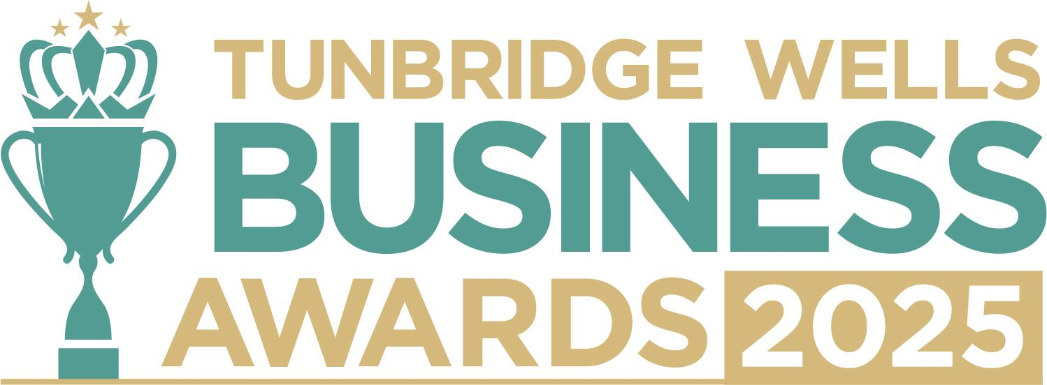

**New Business of the Year, sponsored by GFHR Consulting.** This category celebrates the energy, courage and creativity of new businesses that have launched since **November 2023**. We’d love to hear your story - what inspired you to start, the milestones you’ve already reached and your plans for the future. Information will remain confidential and be reviewed only by our judging panel. **Please submit your entry as a Word document to** [**info@thetncard.com**](mailto:info@thetncard.com) **by 5pm on 20th October. Any supporting evidence should be sent as a separate document (max 2 pages).**

**1. Business information**

|  |  |  |  |
| --- | --- | --- | --- |
| Business name: |  | | |
| Business address: |  | | |
| Date started:  Month, Year |  | No. of employees: Including owners and part-time staff |  |
| 2023 turnover if applicable:  Optional - enables judges  to assess growth |  | 2024 turnover: Optional - enables judges to assess growth |  |
| Website address: |  | | |
| Social media links: |  | | |

**2. Applicant information**

|  |  |
| --- | --- |
| Name: |  |
| Role: |  |
| Email and phone number: |  |

**3. About your business**

3a. When was your business officially launched? Maximum 100 words.

3b. Describe your business in one sentence.

3c. What inspired you to start your business? Maximum 300 words.

3d. What makes your business unique or different from your competitors? Maximum 300 words.

**4. Achievements and future plans**

4a. What milestones or successes has your business achieved so far? Maximum 300 words.

4b. Have you introduced any innovative ideas, products or strategies? Maximum 300 words.

4c. What are your plans for the business in the next 1-3 years? Maximum 300 words.

**5. Sustainability and community**

5a. Do you have sustainability or ethical practices in your business? Maximum 300 words.

5b. Are you involved in any local partnerships or community work? Maximum 300 words.

***Terms and conditions***

*By submitting this entry form, you agree to the following:*

* ***Entry deadline:*** *All entries must be received by 5pm on Monday 20th October 2025. Late entries will not be considered.*
* ***Finalist attendance:*** *Finalists are required to attend the Tunbridge Wells Business Awards evening at Trinity Theatre on Wednesday 19th November 2025. This ensures fairness to all entrants and supports the running of the awards. Please confirm your availability before entering.*
* ***Eligibility:*** *The awards are open to businesses in postcodes TN1 – TN6, Bidborough and Hawkhurst.*
* ***Accuracy of information:*** *All comments made on your application form, and any supporting evidence provided, must be accurate. Entries may be fact-checked, and additional evidence or information may be requested.*
* ***Judging:*** *The judges’ decision is final. We are unable to provide feedback, and entries will not be returned.*
* ***Publicity:*** *By entering the Tunbridge Wells Business Awards, you agree to participate in publicity relating to the awards, including the use of any photography taken before or at the event.*