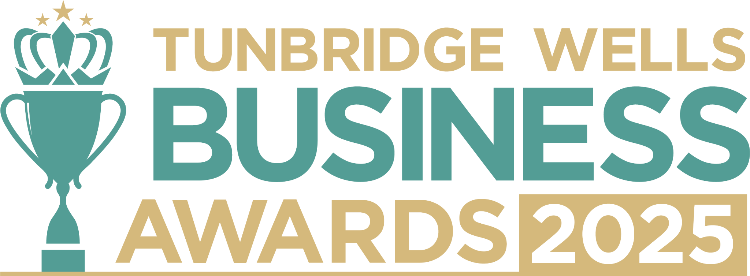

**Businessperson of the Year, sponsored by Charles Stanley.** Have you played a key role in the success of your business over the past year? This award celebrates individuals (owners, leaders and employees) who bring drive, vision, and dedication to their work. We’d love to hear about your motivation, entrepreneurial outlook and commitment to achieving results, as well as the difference you’ve made to your business and community. Information will be treated in confidence and reviewed only by our judging panel. **Please submit your entry as a Word document to** [**info@thetncard.com**](mailto:info@thetncard.com) **by 20th October. Any supporting evidence should be sent as a separate document (max 2 pages).**

**1. Applicant information**

|  |  |  |  |
| --- | --- | --- | --- |
| Name: |  | | |
| Role: |  | Date started role: |  |
| Business name: |  | | |
| Email and phone number: |  | | |
| LinkedIn profile (if applicable): |  | | |

**2. Business information**

|  |  |  |  |
| --- | --- | --- | --- |
| Business address: |  | | |
| Year business was founded: |  | Date you joined the business: |  |
| Website address: |  | | |
| Social media links: |  | | |

**3. About your business**

3a. Describe your business in one sentence.

3b. What is your role within the business, and how do your responsibilities contribute to its success? Maximum 300 words.

**4. Leadership and vision**

4a. What are your key achievements as a business leader over the past year? Maximum 300 words.

4b. What challenges have you faced and what did you learn from overcoming them? Maximum 300 words.

4c. How do you inspire and support the people you work with? Maximum 300 words.

4d. What strategies have you implemented that have significantly contributed to your business or team’s success, and how have these strategies made a real difference to your business or team? Maximum 300 words.

**5. Innovation and growth**

5a. What makes your approach (whether entrepreneurial, creative, or leadership-focused) stand out in your industry? Maximum 300 words.

5b. What are the long-term goals you’ve set for your business or career and how do you plan to achieve them? Maximum 300 words.

***Terms and conditions***

*By submitting this entry form, you agree to the following:*

* ***Entry deadline:*** *All entries must be received by 5pm on Monday 20th October 2025. Late entries will not be considered.*
* ***Finalist attendance:*** *Finalists are required to attend the Tunbridge Wells Business Awards evening at Trinity Theatre on Wednesday 19th November 2025. This ensures fairness to all entrants and supports the running of the awards. Please confirm your availability before entering.*
* ***Eligibility:*** *The awards are open to businesses in postcodes TN1 – TN6, Bidborough and Hawkhurst.*
* ***Accuracy of information:*** *All comments made on your application form, and any supporting evidence provided, must be accurate. Entries may be fact-checked, and additional evidence or information may be requested.*
* ***Judging:*** *The judges’ decision is final. We are unable to provide feedback, and entries will not be returned.*
* ***Publicity:*** *By entering the Tunbridge Wells Business Awards, you agree to participate in publicity relating to the awards, including the use of any photography taken before or at the event.*