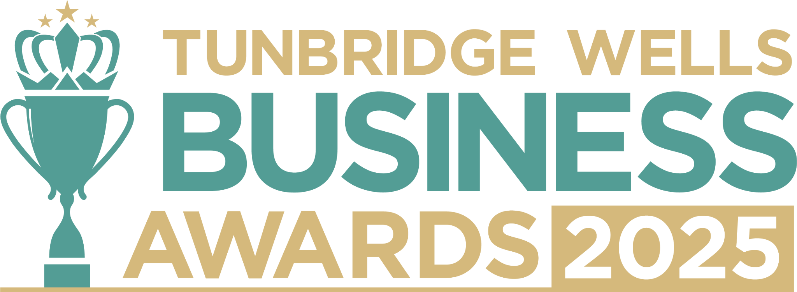

**Food and Drink Award, sponsored by Thomson Snell & Passmore.** Are you the owner of a food or drink business that brings flavour, creativity and community spirit to Tunbridge Wells? We’d love to hear what makes you stand out in your sector, and how you’re making a positive difference in our community. Entries will be treated in confidence and reviewed only by our judging panel and team. **Please submit your entry as a Word document to** [**info@thetncard.com**](mailto:info@thetncard.com) **by 20th October. Any supporting evidence should be sent as a separate document (max 2 pages).**

**Would you like invitations to the sponsor’s Food & Drink Networking Club? Tick here** [ ]

**1. Business information**

|  |  |  |  |
| --- | --- | --- | --- |
| Business name: |  | | |
| Business address: |  | | |
| Year started: |  | No. of employees: Including owners and part-time staff |  |
| 2023 turnover:  Optional - enables judges  to assess growth |  | 2024 turnover: Optional - enables judges to assess growth |  |
| Website address: |  | | |
| Social media links: |  | | |

**2. Applicant information**

|  |  |
| --- | --- |
| Name: |  |
| Role: |  |
| Email and phone number: |  |

**3. About your business**

3a. Describe your business in one sentence.

3b. Tell us about your food and/or drink offering, and the customers or communities you love to serve. Maximum 300 words.

3c. What makes your food or drink business unique, and how do you stand out in a competitive market? Maximum 300 words.

**4. Achievements and impact**

4a. What major achievements or milestones has your business reached in the past year? Maximum 300 words.

4b. How do you ensure your team is supported and motivated to deliver great service? Maximum 300 words

4c. How have you demonstrated innovation in the food and drink industry, whether through your menu, sourcing, customer experience or new ways of doing business? Maximum 300 words.

**5. Sustainability and community**

5a. What sustainability or ethical practices are part of your business, and why are they important to you? Maximum 300 words.

5b. Are you involved in any local partnerships or community work? Maximum 300 words.

***Terms and conditions***

*By submitting this entry form, you agree to the following:*

* ***Entry deadline:*** *All entries must be received by 5pm on Monday 20th October 2025. Late entries will not be considered.*
* ***Finalist attendance:*** *Finalists are required to attend the Tunbridge Wells Business Awards evening at Trinity Theatre on Wednesday 19th November 2025. This ensures fairness to all entrants and supports the running of the awards. Please confirm your availability before entering.*
* ***Eligibility:*** *The awards are open to businesses in postcodes TN1 – TN6, Bidborough and Hawkhurst.*
* ***Accuracy of information:*** *All comments made on your application form, and any supporting evidence provided, must be accurate. Entries may be fact-checked, and additional evidence or information may be requested.*
* ***Judging:*** *The judges’ decision is final. We are unable to provide feedback, and entries will not be returned.*
* ***Publicity:*** *By entering the Tunbridge Wells Business Awards, you agree to participate in publicity relating to the awards, including the use of any photography taken before or at the event.*