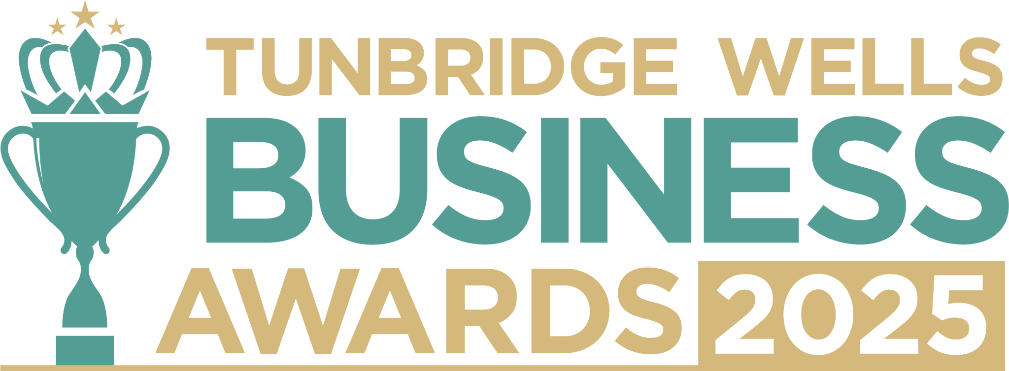

**Micro Business Award, sponsored by TN Recruits.** **Are you a one (or two) person business?** We’d love to hear your story - your creativity, resilience, and what makes your business truly unique. This is your chance to showcase how you’re making an impact as a micro business in our community. Information you share will be kept confidential and reviewed only by our judging panel. **Please submit your entry as a Word document to** [**info@thetncard.com**](mailto:info@thetncard.com) **by 5pm on 20th October. Any supporting evidence should be sent as a separate document (max 2 pages).**

**1. Business information**

|  |  |  |  |
| --- | --- | --- | --- |
| Business name: |  | | |
| Business address: |  | | |
| Year started: |  | Business structure:  *(e.g. sole trader, limited company, partnership)* |  |
| 2023 turnover:  Optional - helps us see your growth story |  | 2024 turnover: Optional - helps us see your growth story |  |
| Website address: |  | | |
| Social media links: |  | | |

**2. Applicant information**

|  |  |
| --- | --- |
| Name: |  |
| Email and phone number: |  |

**3. About you and your business**

**3a.** Describe your business in one sentence.

**3b.** What do you offer through your business, and what inspired you to start this journey? *Maximum 300 words.*

**3c.** As a one (or two) person business, what makes you and your work unique or stand out? *Maximum 300 words.*

**4. Achievements and growth**

**4a.** What milestones or proud moments have you achieved in the past year? *Maximum 300 words.*

**4b.** What challenges have you faced running your business, and how have you overcome them? *Maximum 300 words.*

**5. Innovation, sustainability and community**

**3a.** Have you introduced any new approaches, ideas, products, services or strategies that have helped your business grow or adapt? *Maximum 300 words.*

**3b.** How do you demonstrate innovation through your commitment to sustainability, supporting your community, or collaborating with other local independents? *Maximum 300 words.*

***Terms and conditions***

*By submitting this entry form, you agree to the following:*

* ***Entry deadline:*** *All entries must be received by 5pm on Monday 20th October 2025. Late entries will not be considered.*
* ***Finalist attendance:*** *Finalists are required to attend the Tunbridge Wells Business Awards evening at Trinity Theatre on Wednesday 19th November 2025. This ensures fairness to all entrants and supports the running of the awards. Please confirm your availability before entering.*
* ***Eligibility:*** *The awards are open to businesses in postcodes TN1 – TN6, Bidborough and Hawkhurst.*
* ***Accuracy of information:*** *All comments made on your application form, and any supporting evidence provided, must be accurate. Entries may be fact-checked, and additional evidence or information may be requested.*
* ***Judging:*** *The judges’ decision is final. We are unable to provide feedback, and entries will not be returned.*
* ***Publicity:*** *By entering the Tunbridge Wells Business Awards, you agree to participate in publicity relating to the awards, including the use of any photography taken before or at the event.*