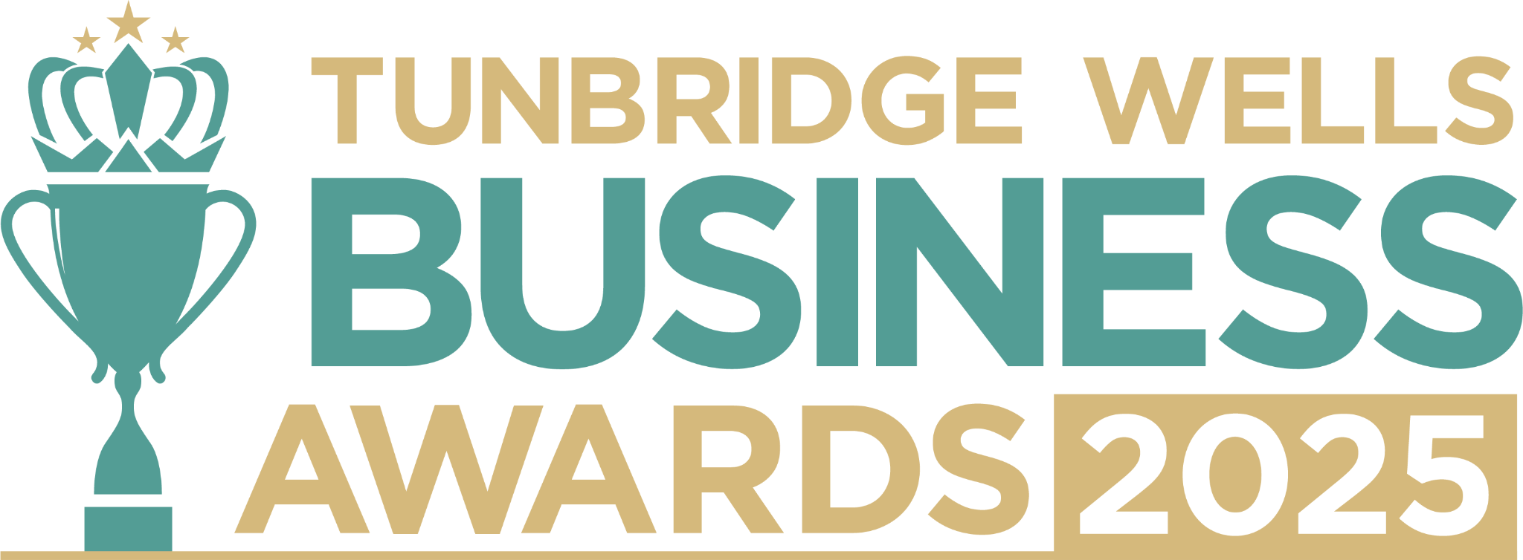

**Small Business Award, sponsored by HR Dept.** Do you run a small business with a team of **less than 20 people?** We’d love to hear your story - how your business has grown, the creativity and innovation you’ve brought to your industry, and what makes you stand out. Everything you share will be kept confidential and seen only by our judging panel and team. **Please submit your entry as a Word document to** [**info@thetncard.com**](mailto:info@thetncard.com) **by 5pm on 20th October. Any supporting evidence should be sent as a separate document (max 2 pages).**

**1. Business information**

|  |  |  |  |
| --- | --- | --- | --- |
| Business name: |  | | |
| Business address: |  | | |
| Year started: |  | No. of people in your team:  Include owners and part-time staff |  |
| 2023 turnover:  Optional - this helps judges  Understand your growth story |  | 2024 turnover: Optional - this helps judges understand your growth story |  |
| Website address: |  | | |
| Social media links: |  | | |

**2. Applicant information**

|  |  |
| --- | --- |
| Your name: |  |
| Your role in the business: |  |
| Your contact details: |  |

**3. About your business**

**3a.** Describe your business in one sentence.

**3b.** What products or services do you offer, and why did you choose this path? *Maximum 300 words.*

**3c.** What makes your small business unique or stand out in your industry? *Maximum 300 words.*

**4. Achievements and innovation**

**4a.** What milestones or proud moments have you achieved in the past year? *Maximum 300 words.*

**4b.** What challenges have you faced as a small business, and how have you overcome them? *Maximum 300 words.*

**4c.** Have you introduced any innovative products, services, or strategies that have helped your business grow or adapt? *Maximum 300 words.*

**5. Sustainability and community**

**5a.** How do you build sustainability into the way you work, your products or your services? *Maximum 300 words.*

**5b.** In what ways does your business support your community, show social responsibility, or collaborate with other independents? *Maximum 300 words.*

***Terms and conditions***

*By submitting this entry form, you agree to the following:*

* ***Entry deadline:*** *All entries must be received by 5pm on Monday 20th October 2025. Late entries will not be considered.*
* ***Finalist attendance:*** *Finalists are required to attend the Tunbridge Wells Business Awards evening at Trinity Theatre on Wednesday 19th November 2025. This ensures fairness to all entrants and supports the running of the awards. Please confirm your availability before entering.*
* ***Eligibility:*** *The awards are open to businesses in postcodes TN1 – TN6, Bidborough and Hawkhurst.*
* ***Accuracy of information:*** *All comments made on your application form, and any supporting evidence provided, must be accurate. Entries may be fact-checked, and additional evidence or information may be requested.*
* ***Judging:*** *The judges’ decision is final. We are unable to provide feedback, and entries will not be returned.*
* ***Publicity:*** *By entering the Tunbridge Wells Business Awards, you agree to participate in publicity relating to the awards, including the use of any photography taken before or at the event.*he use of any photography taken before or at the event.