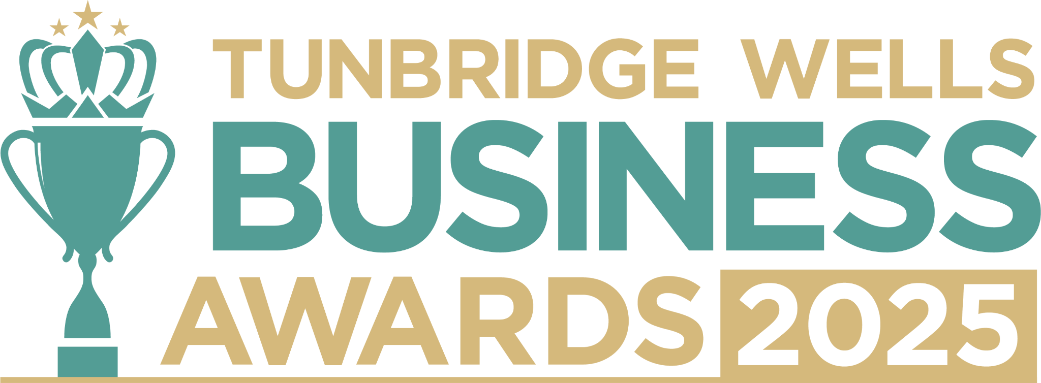

**Large Business Award, sponsored by CooperBurnett Solicitors.** This award recognises larger businesses (a workforce of 20 or more) that demonstrate growth, staff development and real impact in their industry. We’d love to hear your story: what makes your business stand out, how you’ve grown, and the ways you support your staff, community and the wider sector. Information will remain confidential and will be reviewed only by our judging panel. **Please submit your entry as a Word document to** [**info@thetncard.com**](mailto:info@thetncard.com) **before 5pm on 20th October. Any supporting evidence should be sent as a separate document (max 2 pages).**

**1. Business information**

|  |  |  |  |
| --- | --- | --- | --- |
| Business name: |  | | |
| Business address: |  | | |
| Year started: |  | No. of employees: Including owners and part-time staff |  |
| 2023 turnover:  Optional - enables judges  to assess growth |  | 2024 turnover: Optional - enables judges to assess growth |  |
| Website address: |  | | |
| Social media links: |  | | |

**2. Applicant information**

|  |  |
| --- | --- |
| Name: |  |
| Role: |  |
| Email and phone number: |  |

**3. About your business**

3a. Describe your business in one sentence.

3b. What products or services do you offer? Max 300 words Maximum 300 words.

3c. What sets your business apart from competitors? Maximum 300 words.

**4. Achievements and innovation**

4a. What major milestones or successes has your business achieved in the past year, and how have these benefitted your customers, staff or industry? Maximum 300 words.

4b. How has your business grown or evolved over the past year? Maximum 300 words.

4c. Have you introduced any innovative products, services, or business strategies? Maximum 300 words.

4d. Success isn’t just about profit. How do you measure achievements in areas such as staff wellbeing, customer satisfaction, community contribution, or sustainability? Maximum 300 words.

**5. Sustainability and community**

5a. How does your business incorporate sustainability into its operations, products or services, and what future goals have you set? Maximum 300 words.

5b. How does your business support our local community or charitable initiatives, and how do you encourage your team to get involved? Maximum 300 words.

***Terms and conditions***

*By submitting this entry form, you agree to the following:*

* ***Entry deadline:*** *All entries must be received by 5pm on Monday 20th October 2025. Late entries will not be considered.*
* ***Finalist attendance:*** *Finalists are required to attend the Tunbridge Wells Business Awards evening at Trinity Theatre on Wednesday 19th November 2025. This ensures fairness to all entrants and supports the running of the awards. Please confirm your availability before entering.*
* ***Eligibility:*** *The awards are open to businesses in postcodes TN1 – TN6, Bidborough and Hawkhurst.*
* ***Accuracy of information:*** *All comments made on your application form, and any supporting evidence provided, must be accurate. Entries may be fact-checked, and additional evidence or information may be requested.*
* ***Judging:*** *The judges’ decision is final. We are unable to provide feedback, and entries will not be returned.*
* ***Publicity:*** *By entering the Tunbridge Wells Business Awards, you agree to participate in publicity relating to the awards, including the use of any photography taken before or at the event.*